When we read and write data to an internal table that has a header line, we always move unread data from the header line itself.

So, what I mean hear is when we read a record from an internal table, the record is moved to the header line of the internal table, and we access the header line.

When we want to write a record to an internal table, we move the contents to the header line of the internal table, and then the header line gets appended to the table itself.

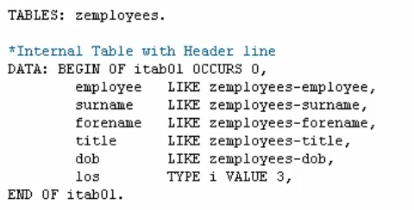



So, what we'll do is have a look at the internal table first. And we can see this hat symbol represents a header line, and then down here you would see all the records as they get filled into the internal table.

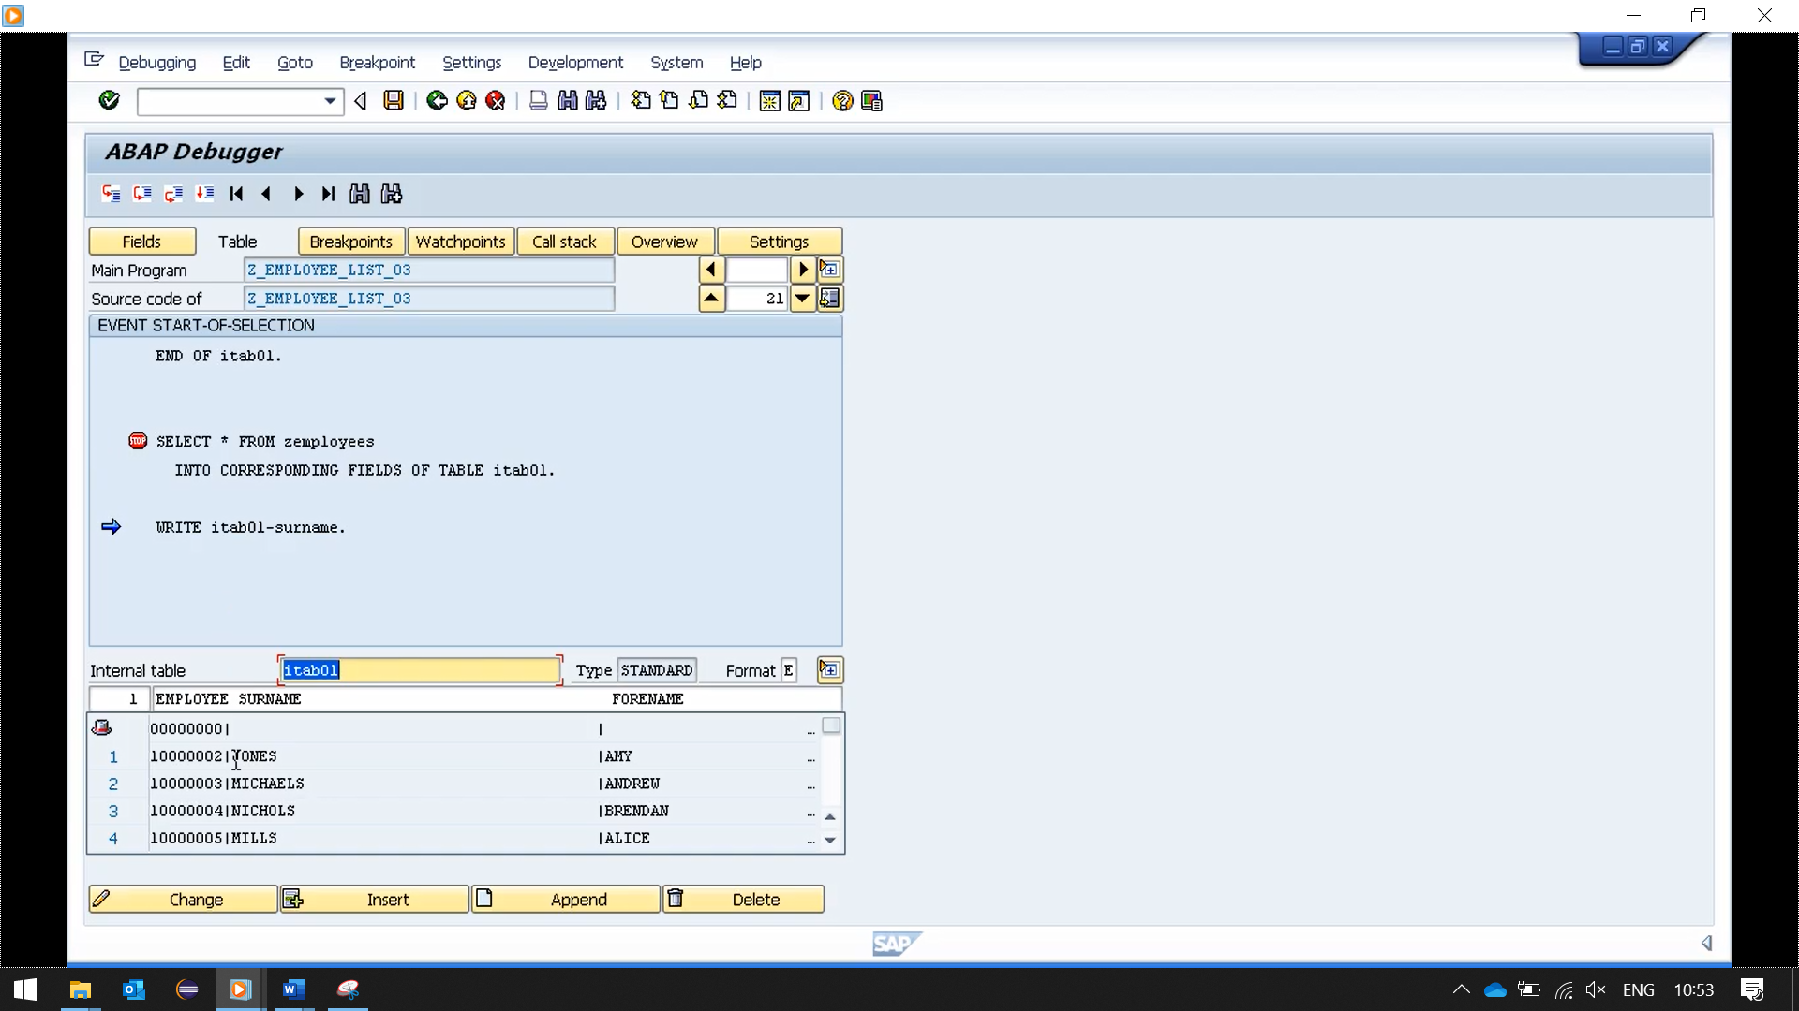

Let's change things around a little bit. Now I want to introduce the append statement.

Where instead of doing an array fetch, collecting the data one record at a time, then select loop. So, the first record will be selected and then we have individual move statements to move our data field by field to the corresponding data in our internal table.

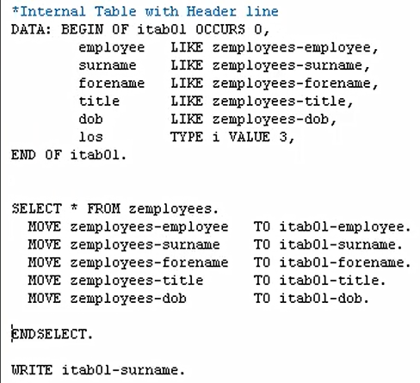

And as you can see, the first move moved the value of the employee field to the header record of our internal table. And so on with the other fields.

Now, one important thing is, I mentioned before when using header records. The system only works with header records and what I mean is it's filling the header record, but there's no code to then say append the completed record to the table. We come to the end of the select.

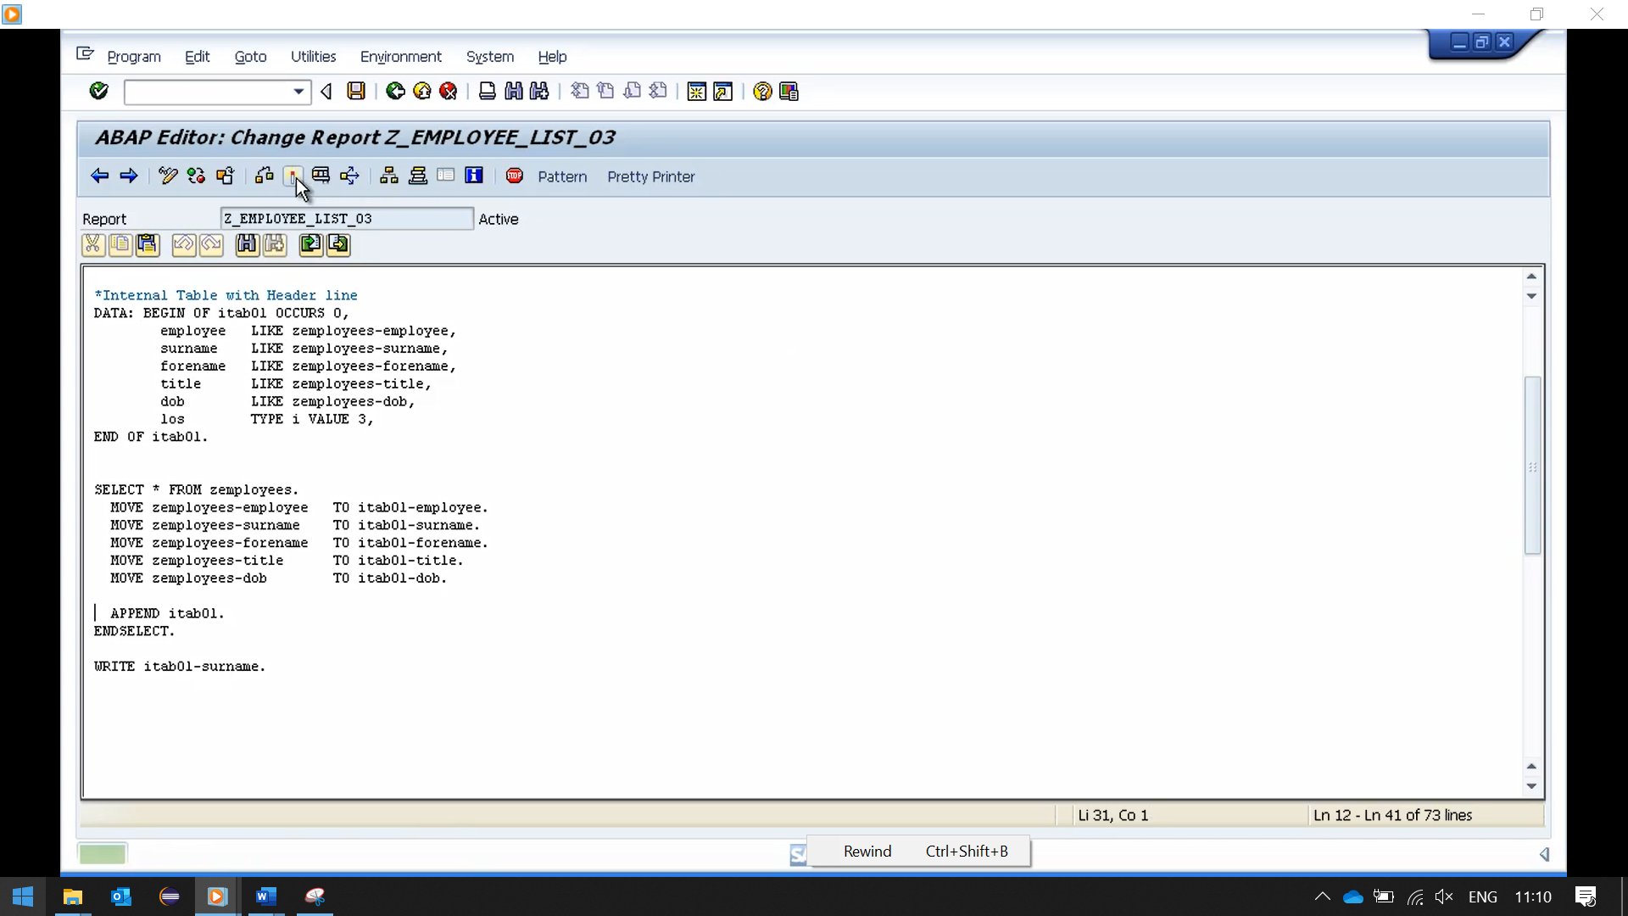

All we need to do to get the header records appended to the table is add our append statement.